Git Branching & Merging

AWS EC2 Auto Scaling, AWS RDS Auto Backup & Restore

AWS Regions & Availability Zones

Docker – Installation, Docker Images, Docker Desktop, Docker Hub, Creating Docker Images

AWS – Amazon Web Service

Amazon.com – Register as a user, select the product, add it to the cart and check out, pay the bill and it’ ll be delivered to your door step.

Amazon.com --- It’s a website which sells many products in online mode.

Amazon.com --- uses lot of micro-services.

AWS – Cloud Service Provider – Many Services over the internet – Cloud Technologies

1. Virtual Machines (EC2 – Elastic Cloud Compute, ECS, EKS - Elastic Container/Kubernetes Service)
2. DB Services (RDS, DynamoDB,…)
3. Storage Services (S3, S3 Bucket ….)
4. Network Services (IGW – Ineternet Gate Way, Security Groups, VPN – Virtual Private Networks)
5. Users & Group policy Services (IAM – Id and Access Management Service..)
6. AR & VR Services
7. AI & ML Services
8. Robotics Services
9. Crypto Services

So many data centers – which is located in various parts of the world.

24 Regions & 77 Availability Zones

24 Regions (US Region/APAC/Africa/Europe

Auto Scaling an Instance [Automatically increasing/decreasing the number of running instances]

When the Load/Demand increases the number of running instances increases.

When the Load/Demand decreases the number of running instances will be reduced.

Git Branching

Git Repo – It’s the virtual place where we can store all the source code and track all the changes to it.

Github repositories will have a default branch (main/master) -- creating a cloud repository

**…or create a new repository on the command line**

echo "# branchandmerge" >> README.md

git init

git add README.md

git commit -m "first commit"

git branch -M main

git remote add origin https://github.com/syskantechnosoft/branchandmerge.git

git push -u origin main

**…or push an existing repository from the command line**

git remote add origin https://github.com/syskantechnosoft/branchandmerge.git

git branch -M main

git push -u origin main

**…or import code from another repository**

You can initialize this repository with code from a Subversion, Mercurial, or TFS project.

[Import code](https://github.com/syskantechnosoft/branchandmerge/import)

.git (Hidden) Folder will be created in the Git Local Repo (A folder in the file system of the desktop/laptop)

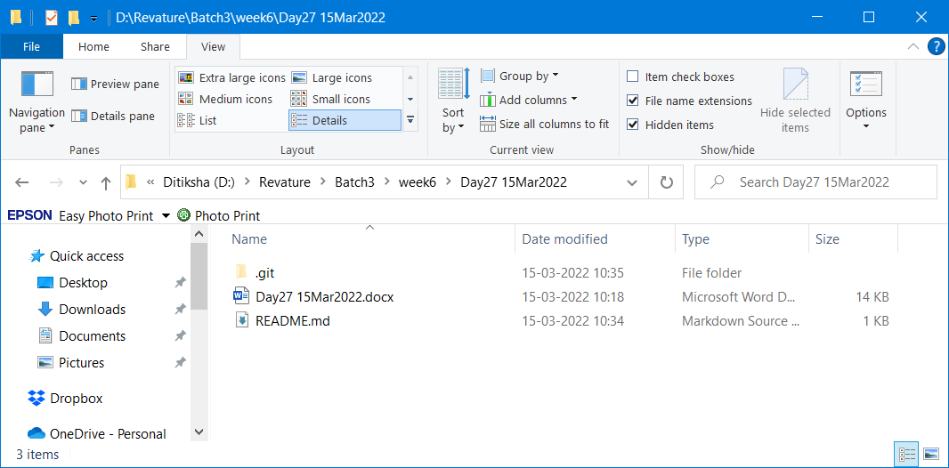



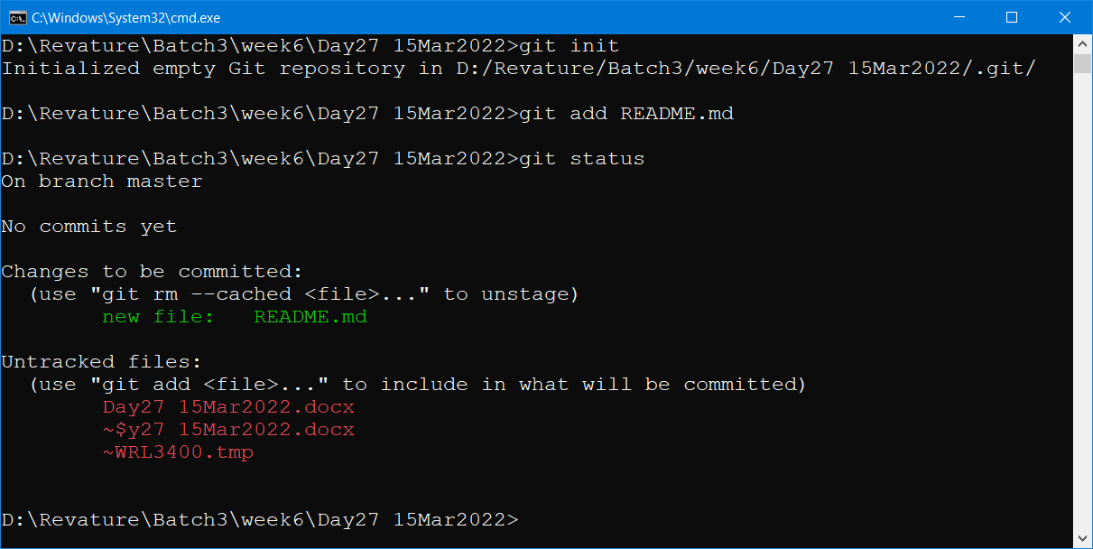

After the ADD command the tracked resource go to the staging area (This is temporary area where the resources will be saved for a shorter duration till executing the commit command)

Git add . (dot represents all the files & folders)

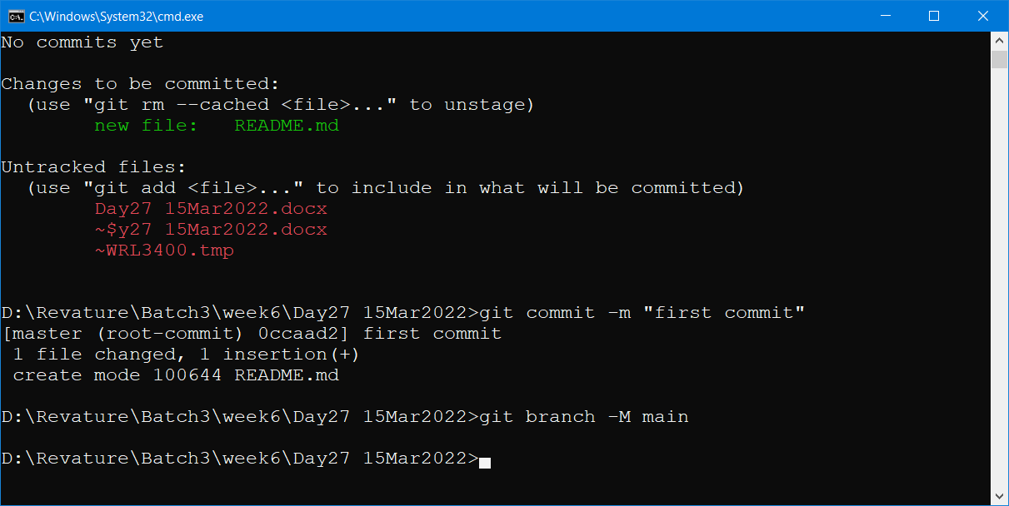

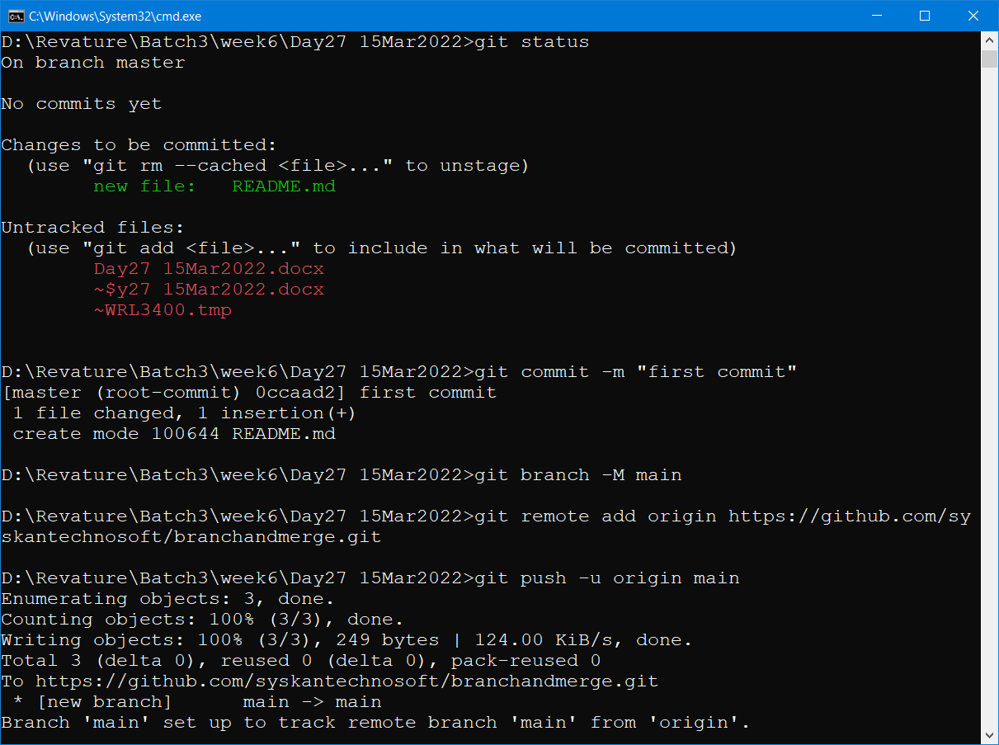

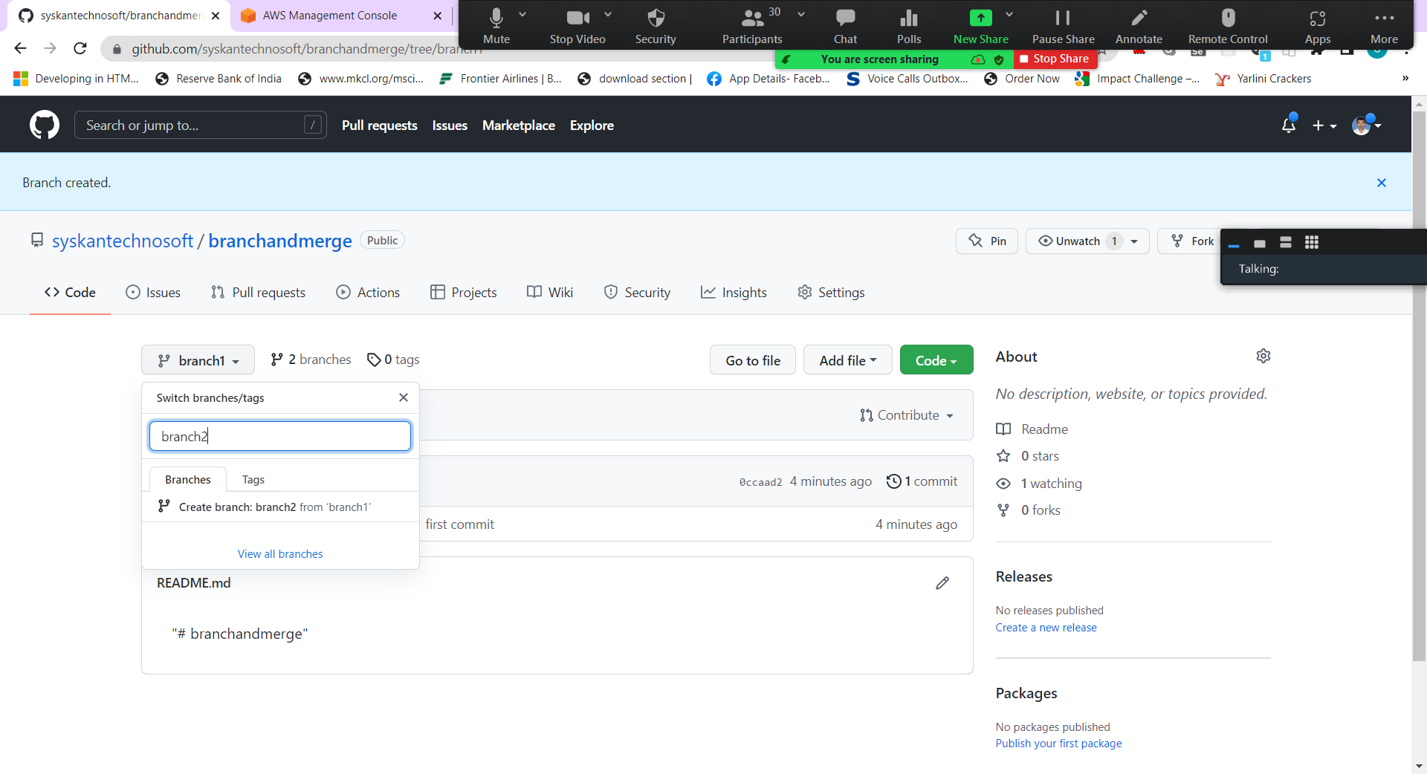



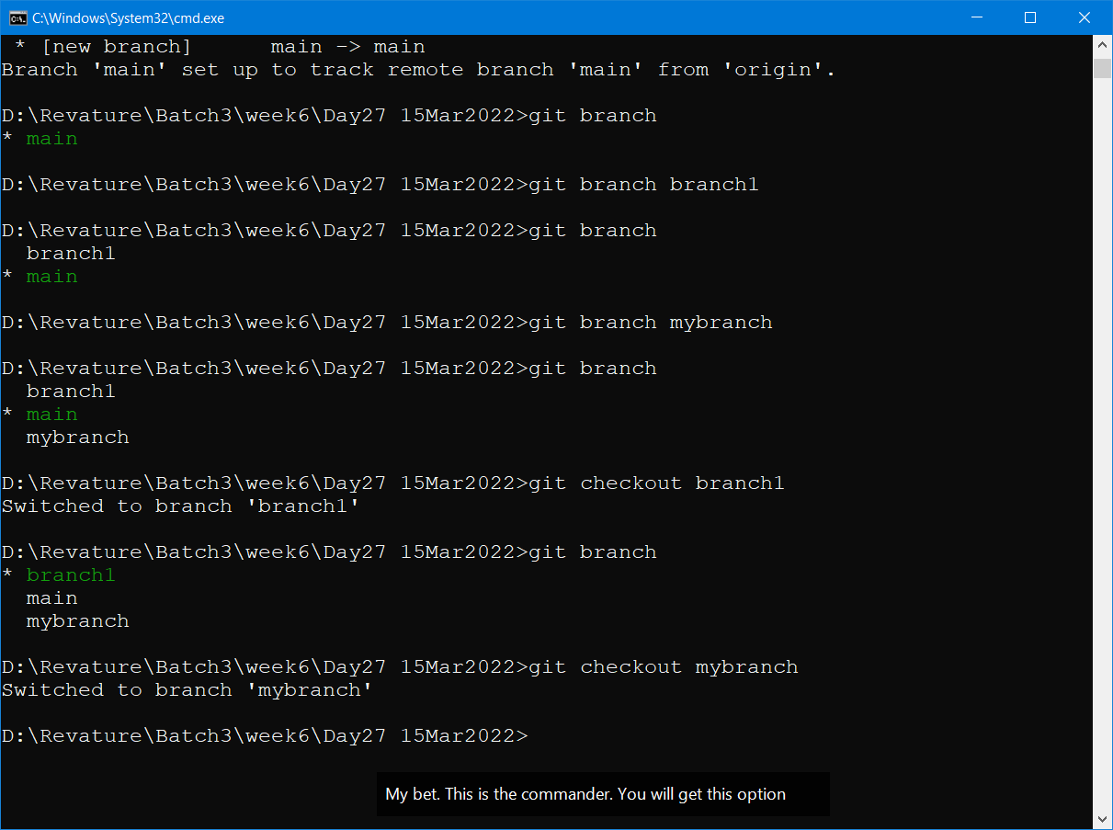

Git branch <existing/new_branch_name> --- To create a new branch or to check the current branch details

Git checkout <name_of_branch> -- To move the HEAD pointer to a different branch

